AIML PROJECT

**Title: Simulation of 8-Puzzle Game**

**Questions and Possible Client Answers**

1. **What is your understanding of the 8-puzzle game?**
   * The goal is to rearrange the tiles into numerical order by sliding them into the open spot.
2. **How do you feel about the user interface of the game?**
   * It’s clean but could use some extra features like a reset button or undo option.
3. **Were the instructions clear on how to play the game?**
   * Yes, they were simple and easy to understand.
4. **Which search algorithm did you find most efficient during gameplay?**
   * Greedy Best-First Search was fast, but A* gave more reliable solutions.
5. **Did you experience any delays or performance issues during the search process?**
   * There was a slight delay when I tried larger puzzles, but overall it was okay.
6. **How effective were the heuristic functions like Manhattan distance and Misplaced Tiles in guiding the solution?**
   * They were very effective, especially the Misplaced Tiles heuristic in simpler configurations.
7. **Were you satisfied with the explanation of how each algorithm works?**
   * Mostly, but a comparison chart for the algorithms would make it easier to understand.
8. **Was the display of the game tree and node exploration clear and informative?**
   * It was good, but I’d like to see an animated exploration process.
9. **Do you feel that the game simulation is an effective educational tool for learning AI algorithms?**
   * Yes, it’s a good introduction to search algorithms and their real-world applications.
10. **Did the performance metrics provide valuable insights?**
    * Yes, but I would like more real-time feedback during the search process.
11. **What additional metrics would you like to see in the performance analysis?**
    * Tracking the number of explored nodes over time would be interesting.
12. **Do you find the visual representation of the game states easy to follow?**
    * Yes, the grid layout is easy to follow.
13. **How would you rate the overall ease of use of the simulation?**
    * It was very user-friendly, though a more advanced settings menu would be nice.
14. **How helpful was the comparison between different search algorithms?**
    * It was helpful, though more real-time comparisons would be interesting.
15. **Did you find the solvability check for initial configurations useful?**
    * Yes, it’s a crucial feature for this kind of puzzle game.
16. **Were the solution path and number of moves clearly displayed?**
    * Yes, but showing the moves visually as they happen would be more engaging.
17. **What improvements would you suggest for the output display?**
    * Add a visual chart or graph summarizing the performance at the end.
18. **Did the search algorithms always lead to an optimal solution in your experience?**
    * Usually, but Greedy Best-First didn’t always find the shortest solution.
19. **Would you like additional puzzles or challenges added to the game for further learning?**
    * Yes, having more levels with increasing difficulty would be great.
20. **How likely are you to recommend this simulation for educational purposes in AI courses?**
    * Very likely.

Geo-tag Photo: -

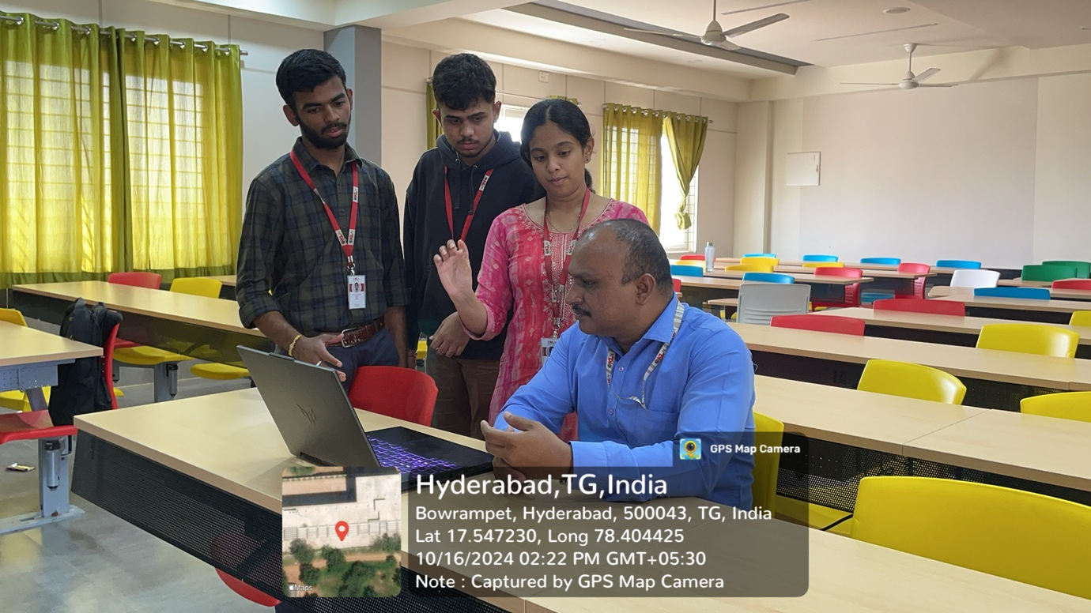

**2320030182 – Sadhana**

**2320030185 – Avinash**

**2320030191 - Jayakrishna**